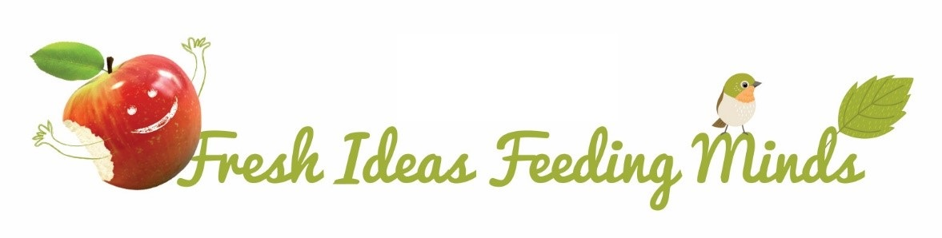

Welcome to our Spring / Summer 2021 Allergen Aware Menu
All menu items are free from 13 of the recognised Allergens other than Fish.

Allergen Aware Menu | Spring / Summer 2021

Week One | Monday | Tuesday | Wednesday | Thursday | Friday
Option 1 | Allergen Free Pasta Bake | Allergen Free Pasta Bolognese | Roast Chicken & Gravy | All Day Breakfast with Diced Potatoes | GF Fish Fingers
Option 2 (Vegan) | Little Green Devils Kids Plant Burger * | Vegetable Sausages * | Potato Topped Vegetable Pie | Cauliflower & Tomato Bake | Vegan Stuffed Sweet Potato
Sides | Sweet Potato Wedges, Baked Beans & Sweetcorn | Farmhouse Mixed Vegetables | Roast or Mashed Potato, Cabbage and Carrots | Baked Beans, Grilled Tomatoes and Mushrooms | Chips, Peas or Baked Beans or Salad Sticks
Desserts | Allergen Free Flapjack | Pip Organic Lolly | Fresh Fruit Platter | Fruit Jelly & Vegan Ice Cream (contains Coconut) | GF Oat Cookie
Week starting: | 19/04/21 ; 10/05/21 ; 07/06/21 ; 28/06/21 ; 19/07/21

Week Two | Monday | Tuesday | Wednesday | Thursday | Friday
Option 1 | Allergen Free Chilli Con Carne & Mexican Rice | Allergen Free Pizza | Roast Turkey & Gravy | Chicken & Vegetable Kebabs with Rice | GF Fish Fingers
Option 2 (Vegan) | Curried Potato & Chickpea Cake | Allergen Free Pasta Bake | Vegetable Crumble | Moroccan Vegan Balls in Tomato Sauce & GF Pasta | Vegetable Sausage
Sides | Farmhouse Mixed Vegetables | Wedges, Baked Beans or Sweetcorn | Roast or Mashed Potato, Cabbage and Carrots | Sweetcorn & Green Beans | Chips, Peas or Baked Beans or Salad Sticks
Desserts | Allergen Free Flapjack | Fruit Jelly & Vegan Ice Cream (contains Coconut) | Fresh Fruit Platter | Pip Organic Lolly | GF Shortbread Biscuit
Week starting: | 26/04/21 ; 17/05/21 ; 14/06/21 ; 05/07/21

Week Three | Monday | Tuesday | Wednesday | Thursday | Friday
Option 1 | Captains Pasta Bake-contains FISH | Chicken & Vegetable Potato Topped Pie | Roast Gammon & Gravy | Gluten Free Beef Burger* | GF Fish Fingers
Option 2 (Vegan) | Allergen Free Pizza | Swedish Style Balls in Tomato Sauce & GF Pasta | Allergen Free Tomato Tumble | Little Green Devils Plant Burger with Vegan Cheese* | Sticky Vegetable Sausage
Sides | Mashed Potato, Baked Beans or Sweetcorn | Peas and Green Beans | Roast or Mashed Potato, Cauliflower and Carrots | Broccoli and Sweetcorn | Chips, Peas or Baked Beans or Salad Sticks
Desserts | Pip Organic Lolly | Apple Crumble & Vegan Ice Cream (contains Coconut) | Fresh Fruit Platter | Allergen Free Flapjack | GF Oat Cookie
Week starting: | 03/05/21 ; 24/05/21 ; 21/06/21 ; 12/07/21

- Available with gluten free seeded bap (contains EGG)

